**FUNCTIONAL AND TECHNICAL COMBINED DOCUMENTATION**

**Page (30): Home (Front End Url:** http://localhost:8100/page30/Page30)

**Functional Picture:**

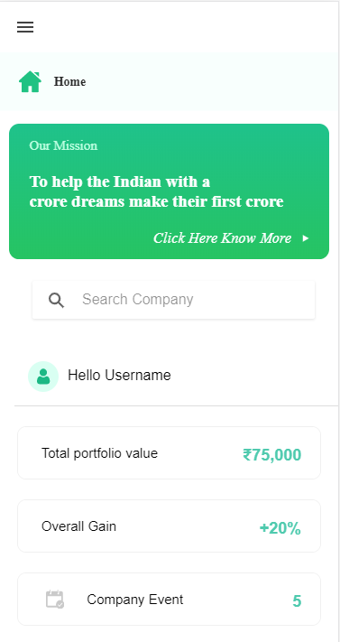

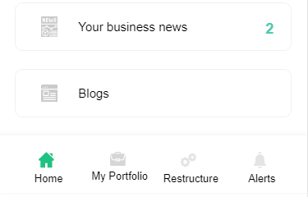

**In this Page, the user can see his over portfolio value and its overall gain. They can also view Company Events and Business news.**

**Technical Explanation (Front End and Back End):**

**In Page30.tsx, we are calling following 3 API’s:**

1. RSSFeedParserAPI: see backend python file. In this we are doing GET requests.
2. BusinessNewsAPI: see backend python file. In this we are doing GET requests.
3. MyPortfolioAPI: see backend python file. In this we are doing GET requests.

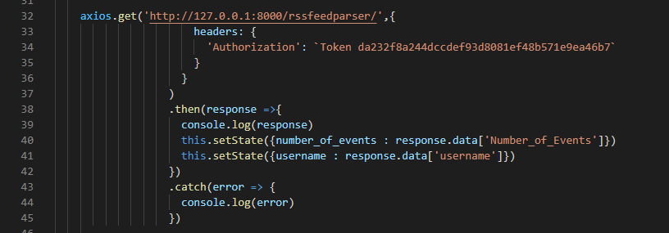

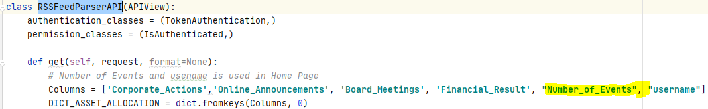

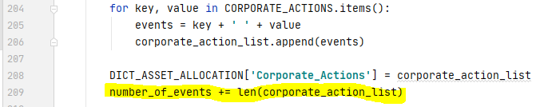

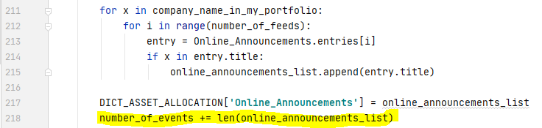

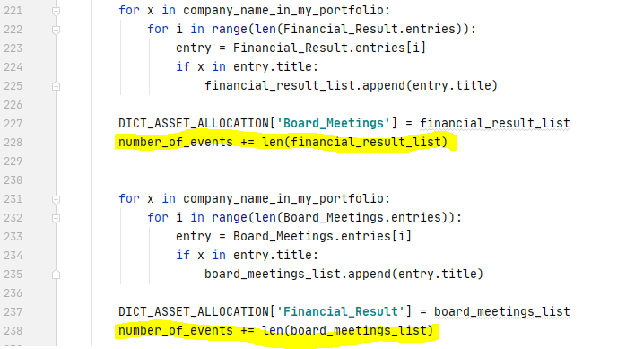

**For Company Events, we are calling RSSFeedParserAPI to get the company events informations.**

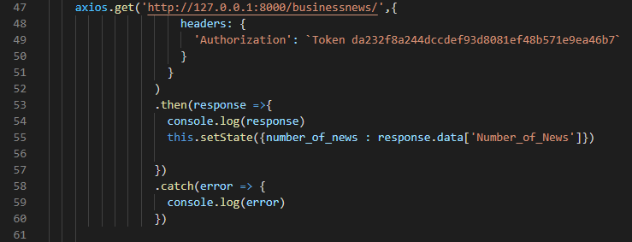

**As you can see, we are calling the** BusinessNewsAPI

**using this url:** [**http://127.0.0.1:8000/businessnews/**](http://127.0.0.1:8000/businessnews/)**. In this we are looking for the business news.**

**Kindly see the given below backend Code for this GET request.**

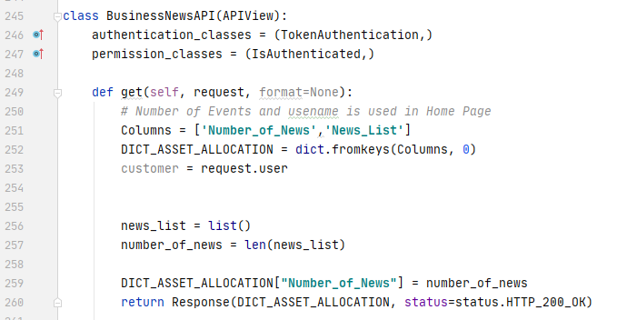

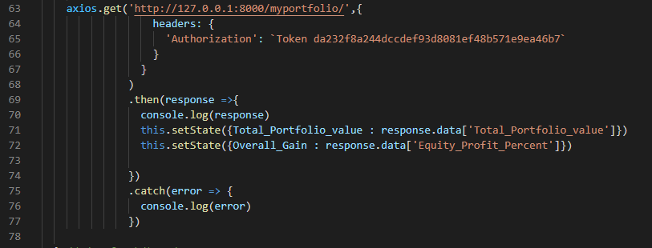

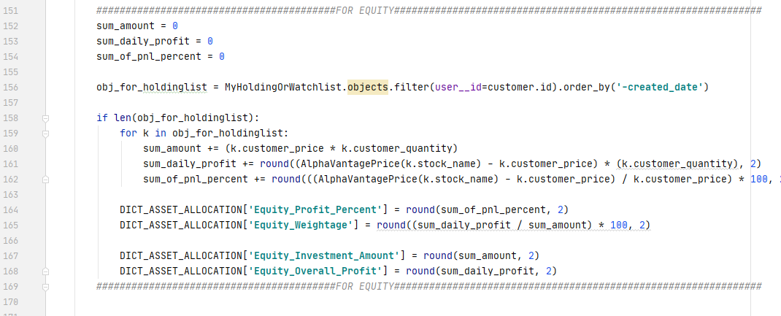

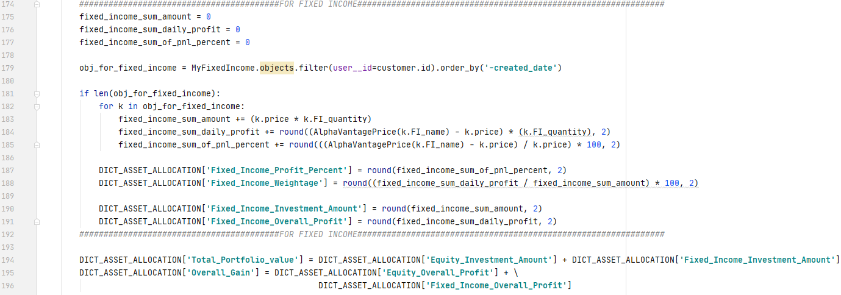

**The Above API is calculating the total portfolio value = Equity Value + Fixed Income Value**

**Overall Gain = Equity overall profit + fixedIncome overall profit**

**DONE!!!**